

CS324

Assignment

|  |  |
| --- | --- |
| Members | ID’s |
| Inoke Nakacia | S11162036 |
| Ajnesh Prasad | S11161043 |
| Avnish Kumar | S11162880 |
| Marineta Wata | S11161571 |

# Part 1: Write-up

## Exercise 1

There are two common systems that is Centralized and Decentralized System. The Leader Election protocol in the assignment is a decentralized system. “It is viewed as a decentralized system on the grounds that the nodes in the leader election protocol convention utilize a ring topology network configuration. Since the nodes are organized in a ring topology which implies that every node is associated with two different nodes, making a circular data path. Unlike the centralized system, each node in the decentralized system can make its own decision. The system does not have central owners, instead they have multiple central owners. Fault tolerance is high for this system by design. That is on the grounds that when at least one central owners or servers fall flat, the others can keep on giving data access to clients. In addition, during the time spent in bidirectional message passing between every node and two other quick neighbor nodes, contingent upon whether the underlying node has a most extreme number higher than possibly either of the prompt neighbor's present greatest number, the neighbor with a most extreme number lesser than the hub sending the message will store a duplicate of the greatest number (resource). In this manner, being the consequence of a decentralized system since there isn't only one central owner of the resources.”

Furthermore, the Leader Election protocol is an unstructured network. “An unstructured P2P network is framed when the overlay joins are set up self-assertively. Such organizations can be effectively built as another companion that needs to join the organization can duplicate existing connections of another node and afterward structure its own connections after some time.”

(Word Count: 273)

## Exercise 2

Yes, it is possible to implement Leader Election Protocol using RPC calls. “The RPC calls used are Callback RPC and Broadcast RPC. Firstly in Callback RPC, peer-to-peer paradigm is facilitated among the participating processes by the Callback RPC. A process can be both a client as well as a server. The Callback RPC will be required as each process in the leader election protocol convention is really going to need the administrations of both a client and a server since it utilizes a ring topology which is P2P. Lastly in Broadcast RPC, upon a sent broadcast packet to the network by the client, it waits for a number of replies. The leader election protocol needs the Broadcast RPC since processes sends messages to more than one process (two processes in exact).”

# PART 2: Implementing Leader Election Protocol using RMI

Screenshots

* Run the Server first.

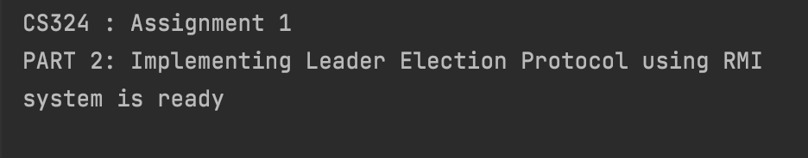

* Run Client

## Results

**Server**



**Client**



# PART 3: Implementing Leader Election Protocol with Peer Register using RMI

Screenshots

Run the Server first

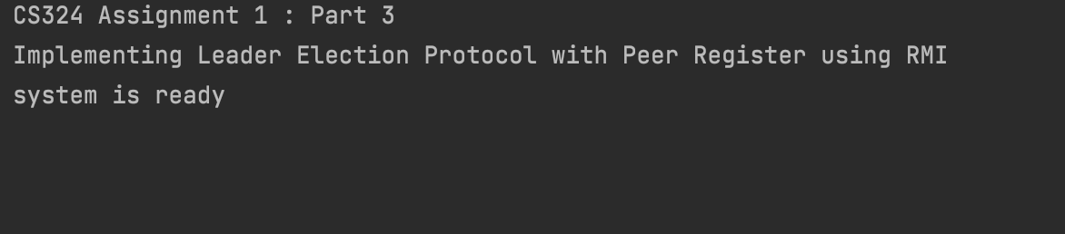

* Run Client

## Results

* Displaying nodes

**Client**

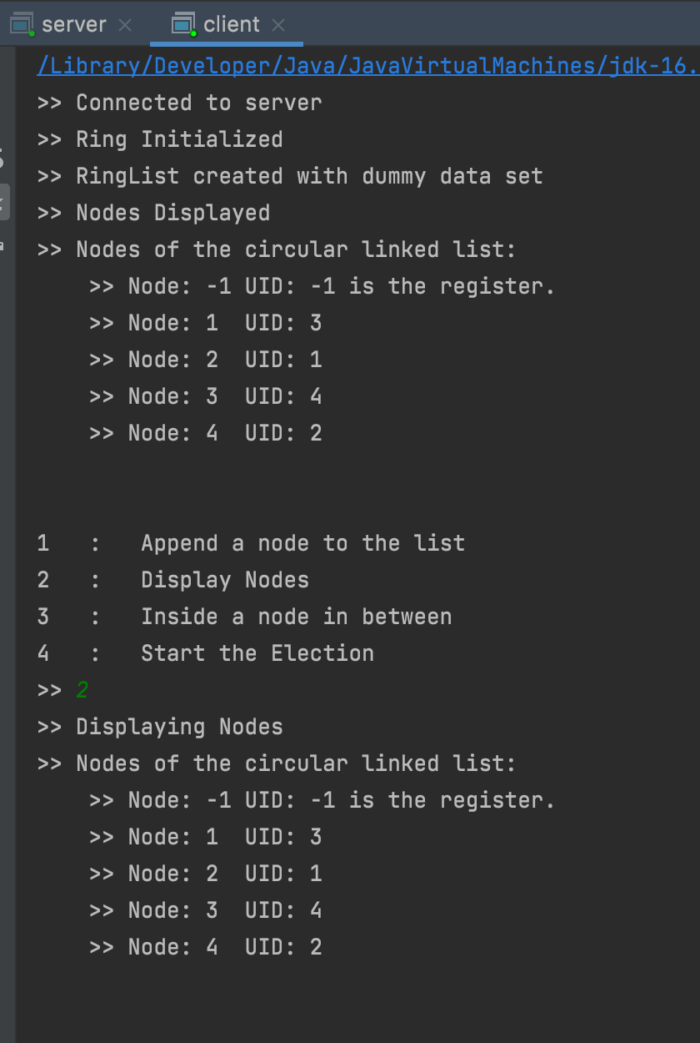

**Server**

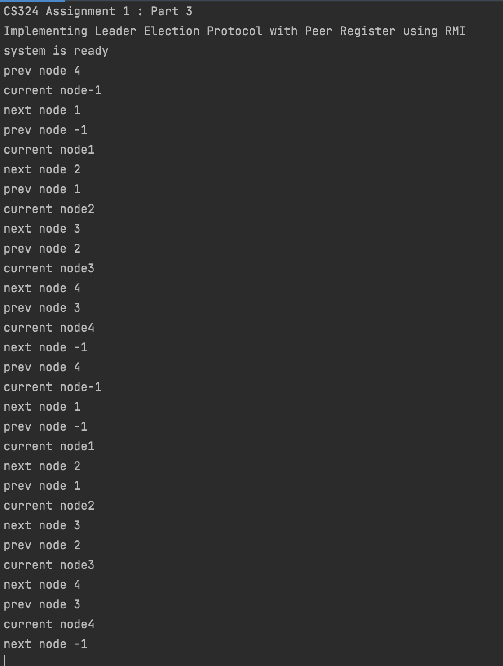

Append a node

Election

* Start Election

**Server**



**Client**



Append a node

* Inserting a node

**Client**



**Server**



Append a node

# MARK ALLOCATION

|  |  |  |  |  |
| --- | --- | --- | --- | --- |
| Members | ID’s | PERCENTAGE | | SIGNATURE |
| Inoke Nakacia | S11162036 | 100% | Inoke Nakacia | |
| Ajnesh Prasad | S11161043 | 100% | Ajnesh Prasad | |
| Avnish Kumar | S11162880 | 100% | Avnish Kumar | |
| Marineta Wata | S11161571 | 100% | Marineta Wata | |